Mac to Windows Remote Desktop (RDP) Guide
Official URL: https://services.smsu.edu/TDClient/180/Portal/KB/Article/4290/Mac-to-Windows-Remote-Desktop-RDP-Guide
Category: Knowledge Base > Information Technology Services > Computer, Device, and Printing Support > Mac to Windows Remote Desktop (RDP) Guide
Tags: mac, windows, RDP, remote
_____________________________________________________

Connecting to a Windows Computer from a Mac Using Remote Desktop (RDP)
SMSU faculty and staff can securely access Windows‑based systems and applications using Remote Desktop Protocol (RDP). RDP allows you to connect to and control a Windows computer from your Mac as if you were physically at that computer.
This guide provides step‑by‑step instructions for setting up and connecting to a Windows computer using a Mac.

Before You Begin
- You must have approved RDP access to the Windows computer.
- You will need your StarID and StarID password.
- If you are off campus, you must connect to the Cisco Secure Client (VPN) before proceeding.

Off‑Campus Users: Connect to the VPN First
If you are off campus, complete these steps before continuing.
If you are on campus, skip to the next section.
- Open Cisco Secure Client.
You can find it in your Applications folder or by using Spotlight Search
(press Command + Space, then type Cisco Secure Client).
- You can find it in your Applications folder or by using Spotlight Search
(press Command + Space, then type Cisco Secure Client).
- Connect to the VPN using your SMSU credentials.
- Once connected, leave Cisco Secure Client running.

Open the Windows App
- Open the Windows App on your Mac.
Locate it in your Applications folder or use Spotlight Search.
- Locate it in your Applications folder or use Spotlight Search.
- In the Windows App, select the Devices tab from the left sidebar.
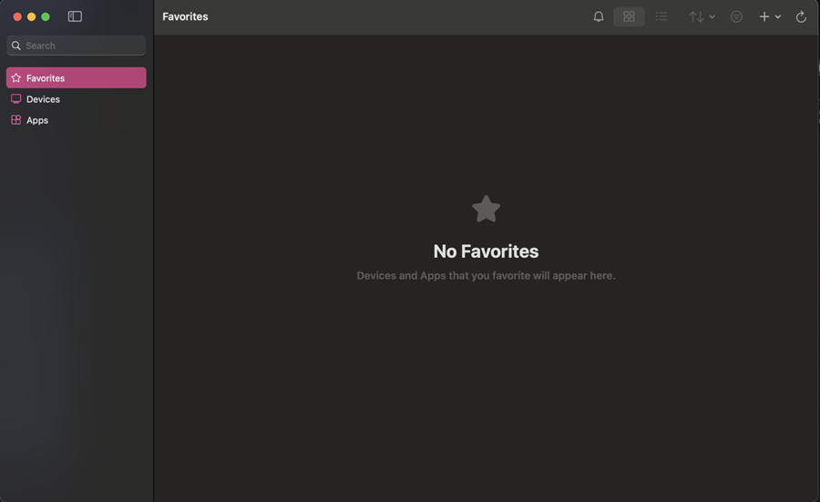
Figure 1: Dark-themed application window showing a sidebar with options for Favorites, Devices, and Apps, with ‘Favorites’ selected, and a main panel displaying a star icon and the message ‘No Favorites’ indicating no saved items.

Add a Windows Computer (First‑Time Setup)
If you have not already added the Windows computer, follow the steps below.

Step 1: Add a New PC
- Select the Plus (+) icon at the top of the Windows App.
- From the menu, choose Add PC.
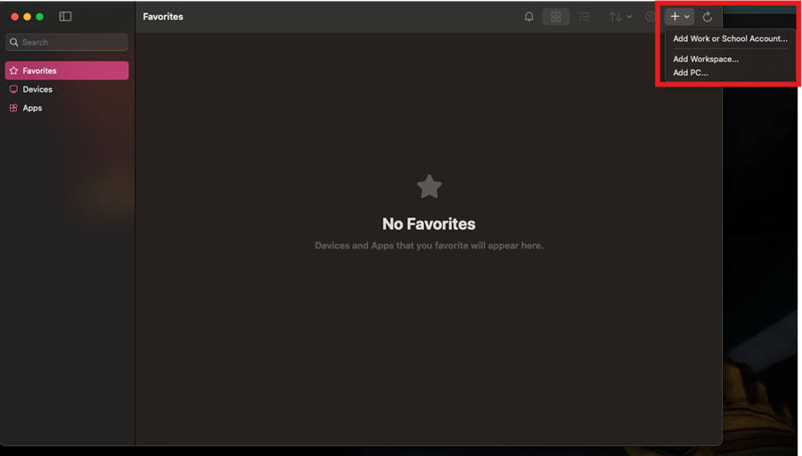
Figure 2: Dark-themed remote desktop application window showing the ‘Favorites’ section with no saved items, and an open menu in the top-right corner listing options to ‘Add Work or School Account…,’ ‘Add Workspace…,’ and ‘Add PC…,’ with the menu highlighted.

Step 2: Configure PC Settings
In the Add PC window, enter the following information:
- PC Name:
Enter the Windows computer name in this format:
windowscomputername.smsu.edu
- Credentials:
Choose one of the following:
Enter your credentials now using StarID@smsu.edu, or
Leave Ask when required selected
- Enter your credentials now using StarID@smsu.edu, or
- Leave Ask when required selected
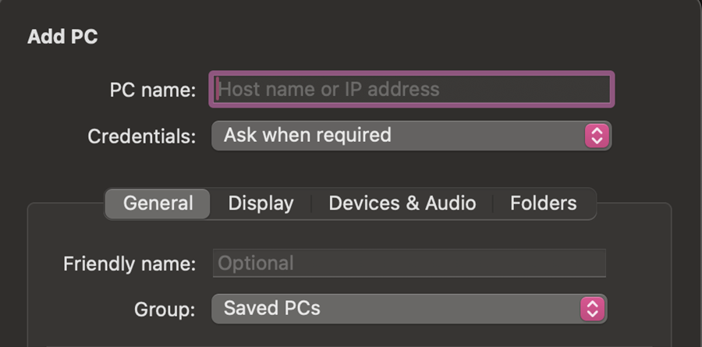
Figure 3: Add PC setup window in a remote desktop application showing an empty ‘PC name’ field with placeholder text ‘Host name or IP address,’ credentials set to ‘Ask when required,’ and additional fields including an optional friendly name and group set to ‘Saved PCs,’ under the General tab.
- Optional - Friendly Name (General tab):
Enter a name to help you recognize the computer (for example, Office PC).
- Gateway (Gateway tab):
Leave this set to No Gateway.
- Reconnect Option:
Ensure Reconnect if the connection is dropped is selected.
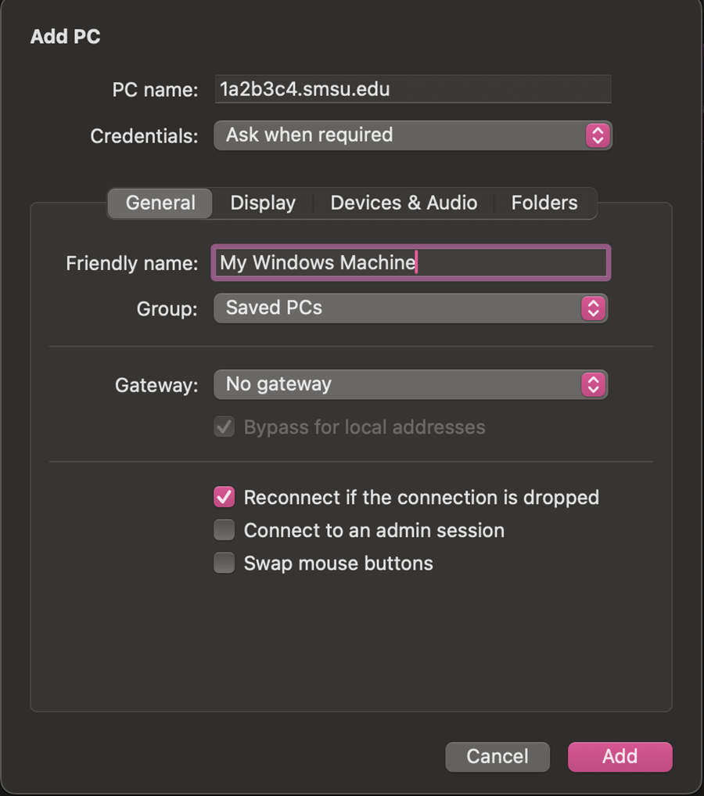
Figure 4: Add PC setup window in a remote desktop application showing fields for PC name (set to ‘1a2b3c4.smsu.edu’), credentials set to ‘Ask when required,’ and a highlighted friendly name field reading ‘My Windows Machine.’ Additional options include group (Saved PCs), gateway (No gateway), and checkboxes such as reconnect if the connection is dropped, with ‘Cancel’ and ‘Add’ buttons at the bottom.
- Optional - Folders (Folders tab):
You may add network folders if needed.
Note: Most users do not need to configure this option. Contact the TRC Helpdesk if assistance is required.

Step 3: Save and Connect
- Select Add to save the computer.
- Double‑click the newly added computer to connect.
- When prompted, enter your credentials:
Username: StarID@smsu.edu
Password: Your StarID password
- Username: StarID@smsu.edu
- Password: Your StarID password
- Select Continue.
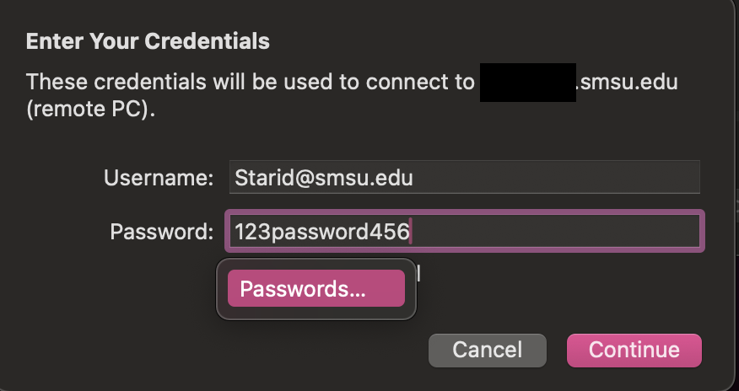
Figure 5: Credentials prompt window titled ‘Enter Your Credentials’ stating the credentials will be used to connect to a remote PC (hostname partially hidden), with fields for username (Starid@smsu.edu) and a filled password field, a ‘Passwords…’ button, and ‘Cancel’ and ‘Continue’ buttons at the bottom.

Connection Complete
You are now successfully connected to the Windows computer using Remote Desktop from your Mac.

Need Help?
If you need assistance or experience issues connecting, contact the Technology Resource Center (TRC):
- Phone: 507‑537‑6111
- Email: TRC@smsu.edu
Accessibility Review & Update Log:
- [x] Content accuracy and link integrity verified
- [x] High-contrast visual hierarchy implemented (Inter and Calibri)
- [x] Image alt-text captions verified (all screenshots captioned)
- [x] PDF attachments scraped and fully inlined directly inside the document
- [x] Outline headers and standard list sequences optimized for screen readers

